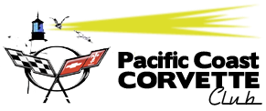
Mail to: Pacific Coast Corvette Club
PO Box 14
Coos Bay, OR. 97420
2021 MEMBERSHIP APPLICATION & RENEWAL FORM
New Application Renewal *
Dues are $30 per year per household.
New members, please submit only $2.50 for each month of a partial year.
I/We hereby apply for membership in the Pacific Coast Corvette Club in the classification indicated above. I/We agree to abide by the Constitution and By-laws of the club and regulations governing it’s operation as adopted by the membership.
Name:__________________________________________ Birthday (month & day)______________
Address:_________________________________City:_____________________Zip:___________
Spouse/Other:____________________________________ Birthday (month & day)______________
Home Phone:____________________ Cell:_______________________
Other Phone:____________________ (**Mark preferred number for contact)
Email:________________________________________________________________
Do you want your phone numbers to be published for other members to see? **Yes____ No_____
CORVETTE INFORMATION
Model:______________________________ Color:______________________ Year:_____________
Special Features:____________________________________________________________________
Model:______________________________ Color:______________________ Year:_____________
Special Features:____________________________________________________________________

Signature of Applicant:_______________________________________Date:___________________
* Renewal members, please complete full form.

